**Eclipse IDE**

Eclipse is an integrated development environment (IDE) for Java and other programming languages like C, C++, PHP, and Ruby etc. Development environment provided by Eclipse includes the Eclipse Java development tools (JDT) for Java, Eclipse CDT for C/C++, and Eclipse PDT for PHP, among others.

This tutorial will teach you how to use Eclipse in your day-2-day life while developing any software project using Eclipse IDE. We will give special emphasis on Java project.

**Features Of Eclipse IDE :**

* Almost everything in Eclipse is a plugin.
* We can extend the functionality of Eclipse IDE by adding plugins to the IDE, maybe for additional programming language or version control system or UML.
* Supports various source knowledge tools like folding and hyperlink navigation, grading, macro definition browser, code editing with syntax highlighting.
* Provides excellent visual code debugging tool to debug the code.
* Eclipse has a wonderful user interface with drag and drop facility for UI designing.
* Supports project development and administered framework for different toolchains, classic make framework, and source navigation.
* Java Eclipse IDE has a JavaDoc facility using which we can automatically create documentation for classes in our application.

**Create a New project :**

Click **File -> New-> Java Project**.

**The following dialog box is presented to the user.**

[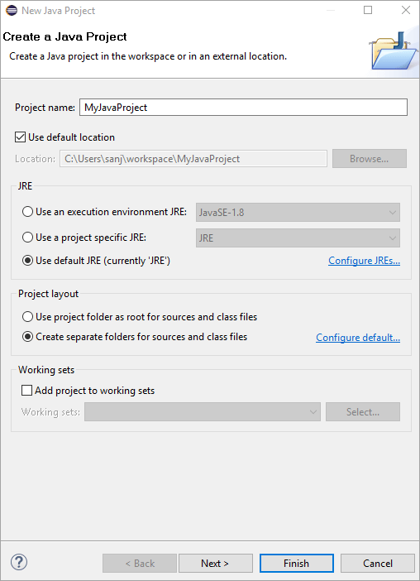](https://cdn.softwaretestinghelp.com/wp-content/qa/uploads/2019/10/Create-A-Java-Project.png)

Specify the project name. Select the option “Use default JRE (currently ‘JRE’) and then click NEXT by keeping the other options unchanged.

**The below dialog box is presented to the user.**

[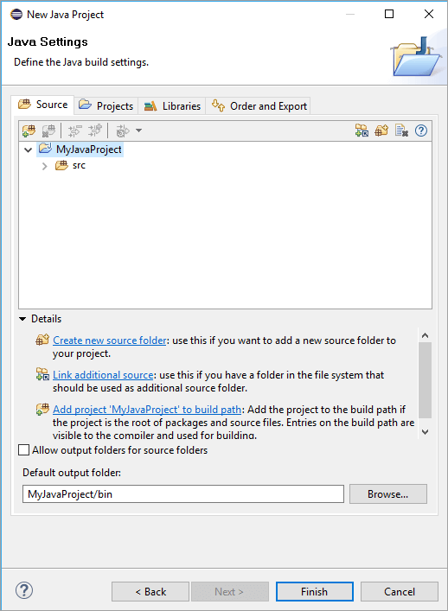](https://cdn.softwaretestinghelp.com/wp-content/qa/uploads/2019/10/ProjectScreen.png)

You are shown the summary of the just created project. In this dialog, you can also specify a default output folder path. Click Finish and the project is created.

**Create a New Class :**

To start Java coding, we need to create different classes. Let us create our first class.

For this right-click Project name in the Package Explorer pane (on the left side). Select **New -> Class**. The following screen will be displayed.

[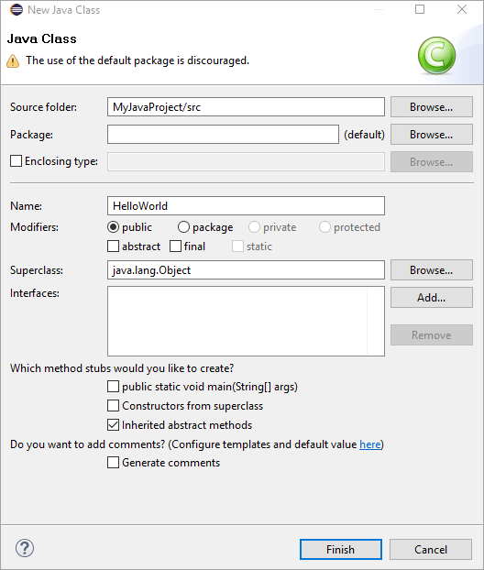](https://cdn.softwaretestinghelp.com/wp-content/qa/uploads/2019/10/NewClass.png)

Fill in the details as per your requirements and click Finish. A new class will be created.

**Write a “Hello, world” program :**

Once the class is created, a corresponding source file is created for this class in the ‘src’ folder of the project and it opens in the editor. In this case, as we created a class named “HelloWorld”, a file named “HelloWorld.java” is created.

**Provide the following code in the ‘HelloJava.java” file.**

|  |
| --- |
| public static void main(String[] args) {  System.out.println("Hello, world!");  } |

Now our first program is ready and we can move on to the “Build and execute” step.

Build And Execute Projects In Eclipse

We can build the project by right-clicking the project name in the Project Explorer and selecting “Build Project”. Actually, there is no need to compile Java projects as Eclipse employs “Incremental Compilation” i.e. each Java statement is compiled as and when it’s entered.

Once the build is successful, run or execute the project. For this, right-click the project name on the Project Explorer and click “Run as”. Then select “Java Application”. This runs your application.

**The following screenshot shows the Eclipse IDE once the application is executed.**

[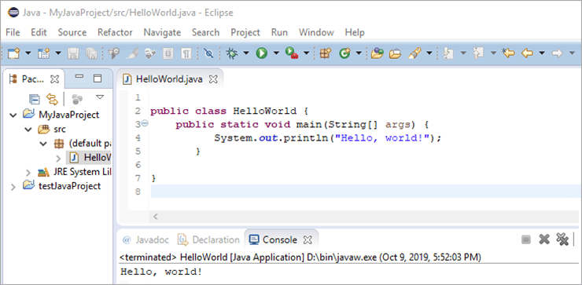](https://cdn.softwaretestinghelp.com/wp-content/qa/uploads/2019/10/CompileExecute.png)